Ques1: Write a program for CRC and Hamming code. Output Format (CRC) Enter data to be transmitted: 1001101 Enter the Generating polynomial: 1011 -------------- Data padded with n-1 zeros : 1001101000 ------ CRC or Check value is : 101 --------- Final data to be sent : 1001101101 ---------Enter the received data: 1001101101 ---- Data received: 1001101101 No error detected.

Source Code

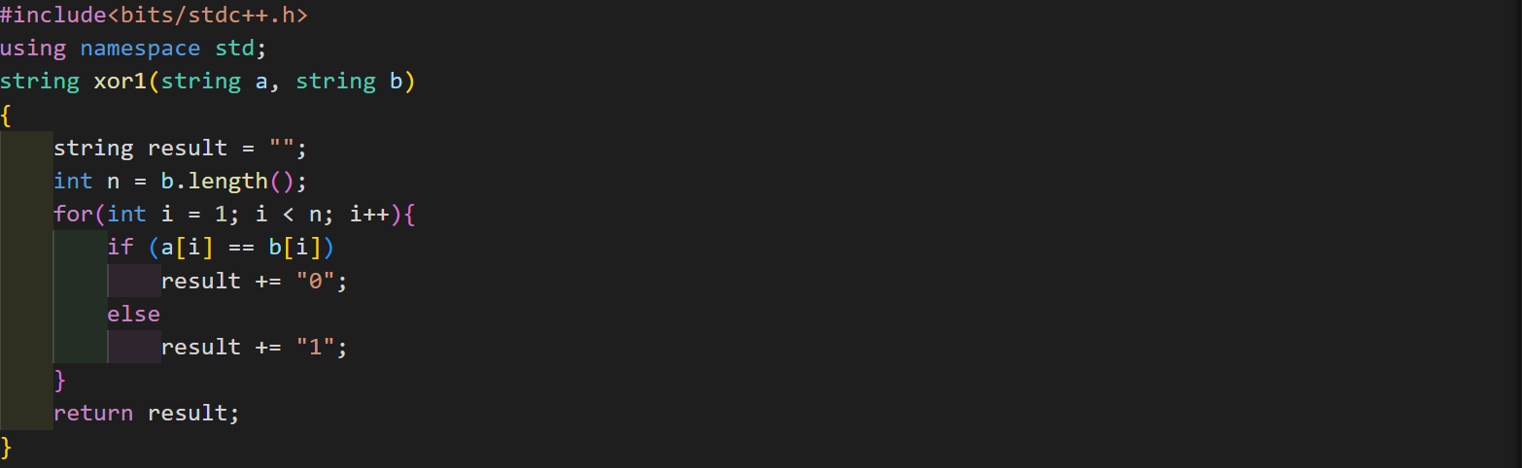

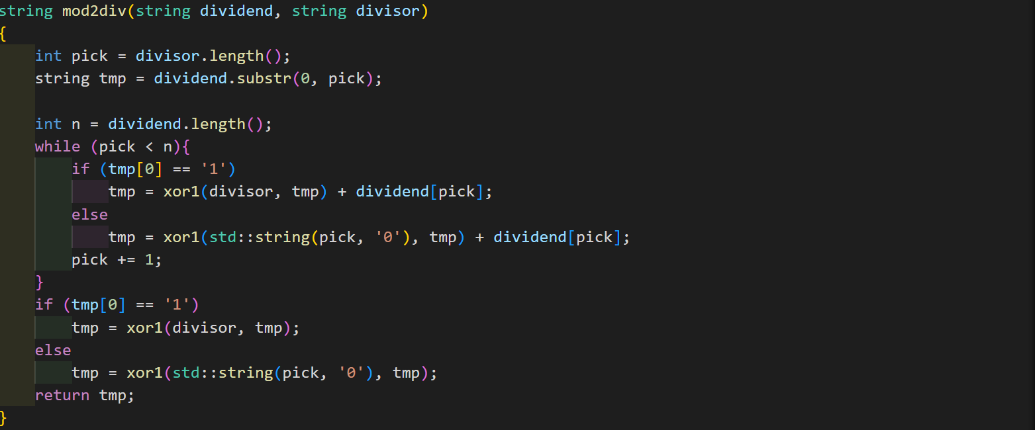

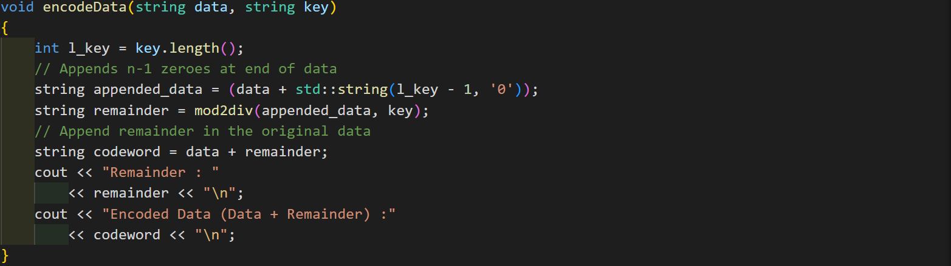

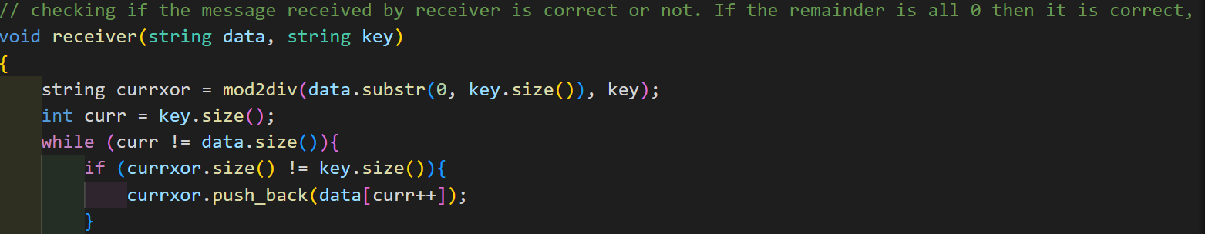

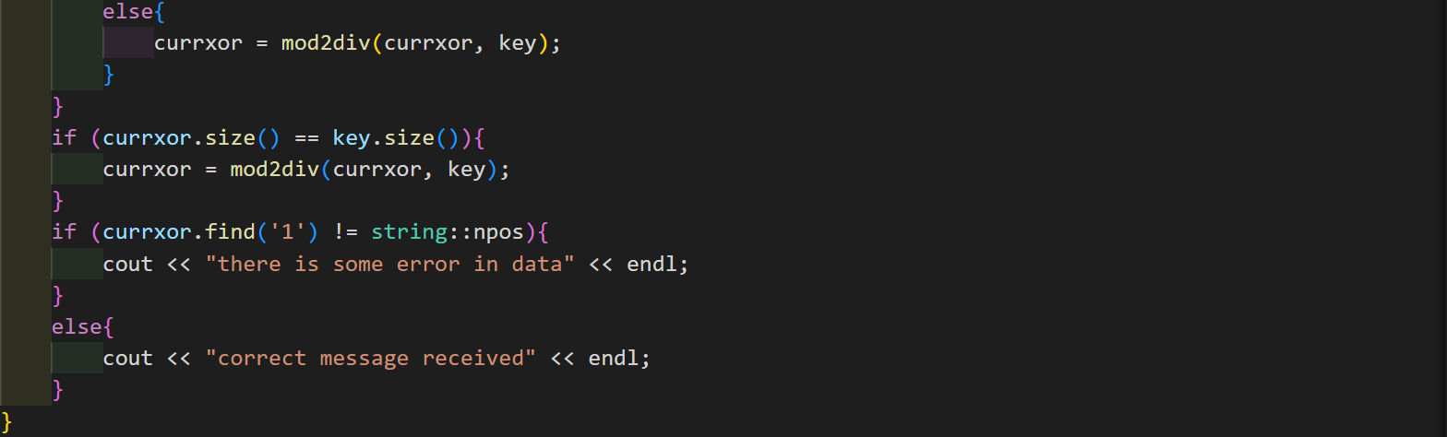

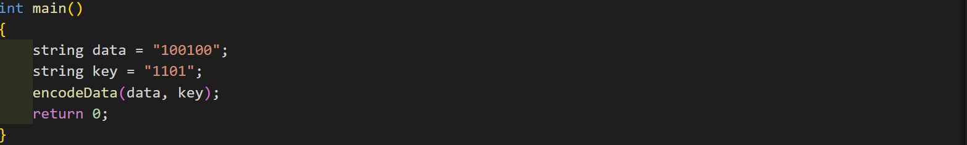

Output

